Example of Paper Format for THIESEL 2018 Conference on Thermo- and Fluid Dynamic Processes in Direct Injection Engines

F. Payri¹, J.M. Desantes¹, X. Margot¹ and P. Miles²

¹CMT – Motores Térmicos. Universidad Politécnica de Valencia. Camino de Vera s/n, E-46022 Valencia, Spain.

E-mail: cmt@mot.upv.es
Telephone: +(34) 963 877 650
Fax: +(34) 963 877 659

²Sandia National Laboratories. USA

E-mail: sandia@national.gov
Telephone: +(1) 12345678
Fax: +(1) 12345679

Abstract. The evolution of the spray tip was studied for an intermittent fuel spray at two surrounding air temperatures. The spray was produced by a single hole diesel injector discharging into a low speed air cross flow at atmospheric pressure. Radial distributions of drop size, axial and radial velocity components have been measured at 10 axial locations by Phase-Doppler Anemometry. Data were obtained during a temporal window of 50 μs for data acquiring times corresponding to the spray tip arrival time at each measured location. A digital visualization system with a CCD camera was used to estimate the spray tip penetration. Two stages were observed in the spray tip temporal evolution. An expression was found to estimate the spray tip penetration.

Notation (optional)
d Nozzle exit diameter.
D₁₀ Arithmetic mean diameter of droplets.
r Spray radius.
1. Introduction
We have prepared this template to facilitate your work when writing your paper to be published in the THIESEL 2018 Conference Proceedings. Please use it as a base, as it will help us obtain a nice uniform format for the Proceedings.
By using this template based on the Springer editors ‘camera ready manuscript’ template, you will also help us simplify the publication process and reduce the publishing time
In the paragraphs that follow, we give examples of paragraph headings, figure legends, table title, citations of references, equations, etc….
2. Important notes (example of heading 1)
2.1 About the page header
Please note the following points:
- The title page of your paper should not bear any page number. Do not change the header that contains the Conference title.
- In the header of the even numbered pages (2, 4, etc…), you should insert the names of all authors. Use ‘Run Head Right’ button to create you header. This automatically numbers the page on the right hand side and as you insert the authors names, they appear on the right hand side too.
- In the header of the odd numbered pages (except page 1), you should insert the paper title. It should not occupy more than 1 line in the header, so please shorten it if necessary. Use the ‘Run Head Left’ button to create the header also. It will automatically insert page numbering and paper title on the left hand side.
2.2 About the text (example of heading 2)
  - The 1st paragraph in each chapter or sub-chapter is NOT indented, the rest are. The indentation means that there is a space at the beginning of the paragraph.
  - The buttons H1, H2, H3 give you automatically the adequate font an format for your 1st, 2nd and 3rd level headings respectively. Examples of how they look are given all along this document.
  - When referring to a figure in a sentence, please use the abbreviation’ Fig. number of figure’. However, if the sentence starts with the word ‘figure’, then you should write ‘Figure’ in full. Examples:
In Fig. 1 the velocity profiles for … are represented.
Figure 2 shows the geometry of the combustion chamber.
  - When referring to an equation, please use the abbreviation Eq. or Eqs. (for several). However, if the sentence starts with the word ‘equation’, please write ‘Equation’ in full.
2.3 About the figures
Please take into account that the Proceedings will be published in black and white. You should therefore make sure that all of your colour figures do not lose information and are readable in black and white. Typically, coloured curves should additionally be marked with different symbols and contour figures should have colour levels that may clearly be distinguished when printed in the ‘gray scale’.
Please, in addition to inserting your figures in the text either by a ‘Link to file’ or ‘Save picture in Document’ option, we would be very grateful if you could supply us with the original graphics file. There are often resolution problems which may be solved if we have the original.
2.3.1 About the figure legend (example of heading 3)
The figure legend has a specific format that you will obtain automatically by clicking on the ‘Figure Legend’ button (font point 9). An example is shown below. Do not end your legend with a dot.
Whenever possible, figures should be placed at the beginning or at the bottom of a page, so as not to interrupt the flow of the text.

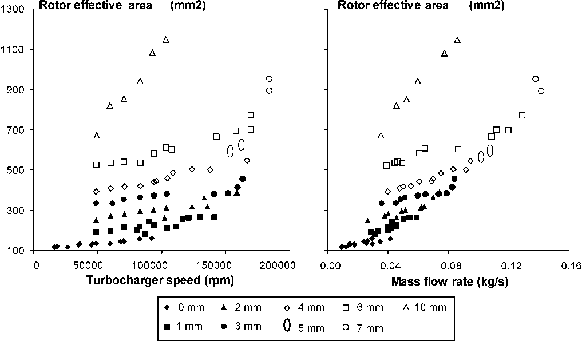
Fig. 1. Example of figure legend (font point 9. Line should not end with a dot)
2.4 About tables
Note that table titles also have a specific format which you will automatically obtain by clicking on the ‘Table Title’ button. It should always be located above the table. An example is given below.

Table 1. Example of table title (must be above the table)
k1 = -0.0430+0.0009 | k2 = -1.429+0.008
k3 = 0.686+0.004 | r2 = 0.986
2.5 About equations
When you click on the ‘Equation’ button, a two cells table is automatically inserted. The box on the left is for the equation itself, the box on the right contains the brackets within which you can write the equation number.
An example is given below:
Ax + by = 0 | (1)

(2)

2.6 About references
2.6.1 Citations in the text
References may be cited in the text in two different ways:

Author name(s) and year of publication in parentheses

- One author: (Payri 1990)
- Two authors: (Payri and Desantes 1995)
- Three or more authors: (Payri et al. 2000)
- Also, (Payri 1990, 1992) for publications by same author(s) in different years
- And (Desantes 1999, 2000; Payri 2001) for several authors cited at the same time

Reference numbers in square brackets

[11, 13, 16] : this format is automatically available by clicking on the [ ] button
2.6.2 Reference list
The reference list should be written in a separate chapter ‘References’ (non-numbered 1st level heading) at the end of your paper. Please order your reference list in alphabetical order, even if you use the [ ] citation format in the text and your list is numbered. If you cite the same author several times, order the corresponding references as follows:

- First, all works by author alone, ordered chronologically by year of publication
- Next, all works by author with co-author, ordered alphabetically by co-authors
- Finally, all works by author with several co-authors, ordered chronologically by year of publication.

Please use the ‘Reference` button to style the list entries, as it will give you automatically the right font (point9).
An example of reference chapter is given below, after the conclusions paragraph.
3 Some examples of text to illustrate all comments above
The turbine geometric model was previously described (Payri et al. 1996) and is based on the representation of the turbine by two ideal nozzles discharging to and from an intermediate chamber, as shown in Fig. 1. The first nozzle represents the stator of the real turbine, which produces the first expansion in the flow. The second nozzle stands for the turbine rotor, and expands further the flow up to the outlet conditions. In between, the intermediate chamber is able to account for the mass accumulation that may take place in the real turbine under pulsating conditions. The volume of this intermediate chamber must be similar to that of the actual volume existing in the turbine, while the values of the nozzle effective sections were calculated using the “nozzle equation”.
3.1 An example of second heading
An important advantage of these simple geometric models is that they do not need additional elements to be introduced in a complete wave action model, such as those widely used in internal combustion engines modelling [11, 13]. Normally, wave action calculation codes are able to compute the flow evolution across an intermediate chamber with several inlets and outlets. Only suitable equations must be programmed to calculate the turbine work and the interaction with the compressor.
In a supercharged turbine, the thermodynamic evolution can be represented on an enthalpy versus entropy diagram such as that shown in Fig. 2. The flow is expanded from the turbine inlet (point 0) to the turbine outlet (point 2) in two stages: the first corresponding to the stator (from 0 to 1) and the second to the rotor (from 1 to 2).
The most significant assumption in this model is the quasi-steady flow behaviour across the nozzles simulating stator and rotor. This hypothesis is commonly employed concerning the boundary conditions in the unsteady flow modelling of engines. In the particular case of turbine modelling, the quasi-steady assumption has been validated by experiments where the deviations were always below 5% (Watson and Janota, 1982).
Figure 5 shows the evolution of the stator effective area versus VGT opening; the points in this plot have been fitted by an exponential equation (20).
Conclusions
We hope this template will be useful to you. If you have any doubts or questions, please do not hesitate in contacting with us directly either per telephone, fax or mail:
Telephone: +34 – 96 387 76 50
Fax: +34 – 96 387 76 59
Mail: secrecon@mot.upv.es

Please do not forget the deadlines:
20th March 2018: 1st version of paper for peer review
25th June 2018: Final version of the paper

We thank you for your cooperation
References
Note: references should preferably be listed in alphabetical order. If you choose to number them, then list them by numbering order.

Benajes J, Luján JM and Serrano JR (2000) Predictive modelling study of the transient load response in a heavy-duty turbocharged diesel engine. SAE paper 2000-01-0583.
Chen H, Hakeem I and Martínez-Botas RF (1996) Modelling of a turbocharger turbine under pulsating inlet conditions. Proceedings of IMechE A04695: vol 210: pp 397-408.
Dale A, Watson N (1986) Vaneless diffuser turbocharger turbine performance. Proceedings of IMechE C110/86: pp 65-76.
Hawley JG, Wallace FJ, Cox A, Horrocks RW and Bird GL (1999) Variable geometry turbocharging for lower emissions and improved torque characteristics. Proceedings of IMechE D00498: vol 213: pp 145-159.

