Paper template for THIESEL 2026 Conference on Thermo- and Fluid Dynamics for Clean Propulsion Powerplants
(Paper Title)
R. Payri¹, J.R. Serrano¹, X. Margot¹ and P. Miles²
¹CMT – Clean Mobility & Thermofluids. Universitat Politècnica de València. Camino de Vera s/n, 46022 Valencia, Spain.
cmt@mot.upv.es

²Sandia National Laboratories. 7011 East Avenue, Livermore, CA 94550, USA
sandia@national.gov
How to cite: Payri, R.; Serrano, J.R.; Margot, X.; Miles, P. 2026. Paper title. THIESEL 2026 Conference on Thermo-and Fluid Dynamics of Clean Propulsion Powerplants. Valencia (Spain), 8-11 September 2026

Abstract
Abstract of between 300 and 400 words…

Keywords: keyword1; keyword2;…
Notation (optional)
d Nozzle exit diameter.
D₁₀ Arithmetic mean diameter of droplets.
r Spray radius.
- Introduction
We have prepared this template to facilitate your work when writing your paper to be published in the THIESEL 2026 Conference Proceedings. Please use it as a base, as it will help us obtain a nice uniform format for the Proceedings, as required by the UPV editorial.
This document can serve as a template for the format of the full text of papers.
In the paragraphs that follow, we give examples of paragraph headings, figure legends, table title, citations of references, equations, etc….
- About the pages’ headers
Please note the following points:
- The title page of your paper should not bear any page number. Do not change the header that contains the Conference title.
- In the header of the even numbered pages (2, 4, etc…), you should insert the paper title. It should not occupy more than 1 line in the header, so please shorten it if necessary (even if you do not shorten the full title on the main page).
- In the header of the odd numbered pages (except page 1), you should insert the names of all authors.
- About the text (example of heading 1)
This document can serve as a template for the format of the full text of papers.
All text, figures, and tables must be included within the template's margins.
Please follow the format for the different headings shown in this document.
  - Fonts and formats (example of heading 2)
The fonts, sizes, and spacing to be used are those indicated in this document, which can be used as a template

Title (example of heading 3)

Headings will have a maximum of three levels, numbered using the decimal system. The main heading (Heading 1) should be written in Arial, B (bold), 11-point font. The second level (Heading 2) should be written in Arial, B (bold), 10-point font. The third level of headings (Heading 3) should be in Arial I (italic), 10-point font. All headings should have a 6-point space after each heading. Do not leave a blank line after each heading; only leave one blank line before starting a new section.

Figure and table captions
Figure and table captions should be written in Arial I (italic) 8 pts. Text included in figures must be of a sufficient size to be legible, that is, the font should not be smaller than 9 pt.
  - Graphics (drawings and photographs) and tables
Since the Conference Proceedings will be edited in pdf format in a USB, figures can be in color. However, please ensure that the quality of the figures is excellent, that the axes units are perfectly readable and the legends also. To facilitate file transfer, a .jpg resolution of approximately 150 kB should be used.
All images and photographs must be embedded in the document.
Figures and tables should be placed close to where they are first cited and, whenever possible, placed at the beginning or at the bottom of a page, so as not to interrupt the flow of the text. A caption titled "Fig." followed by the number should be placed below each image or photograph, and a heading titled "Table" followed by a sequential number should be placed above each table.
Figures, photographs, and tables must be centered. Tables will have border lines at the top and bottom and under the header.

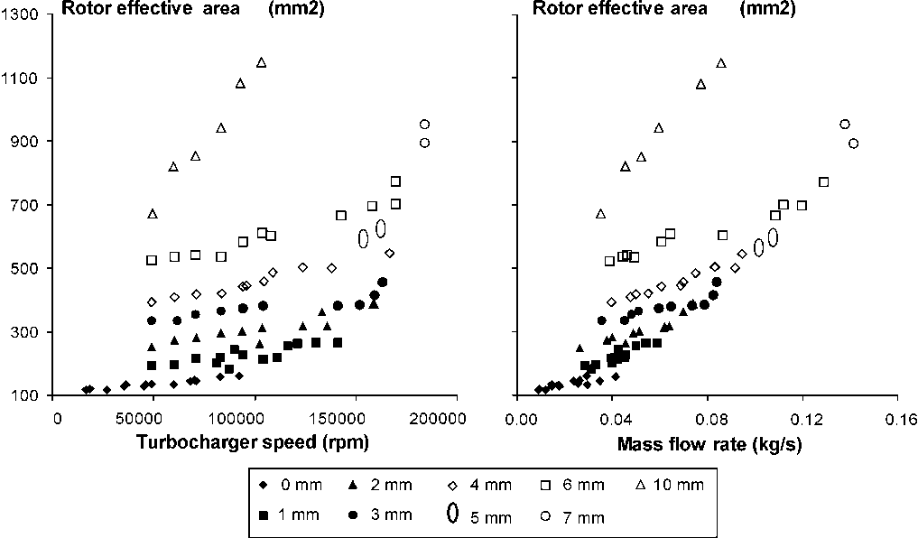
Fig. 1. Example of figure legend (font point 9. Line should not end with a dot)

Table 1. Sustainability Agenda. Source: Edwards, B (2005)
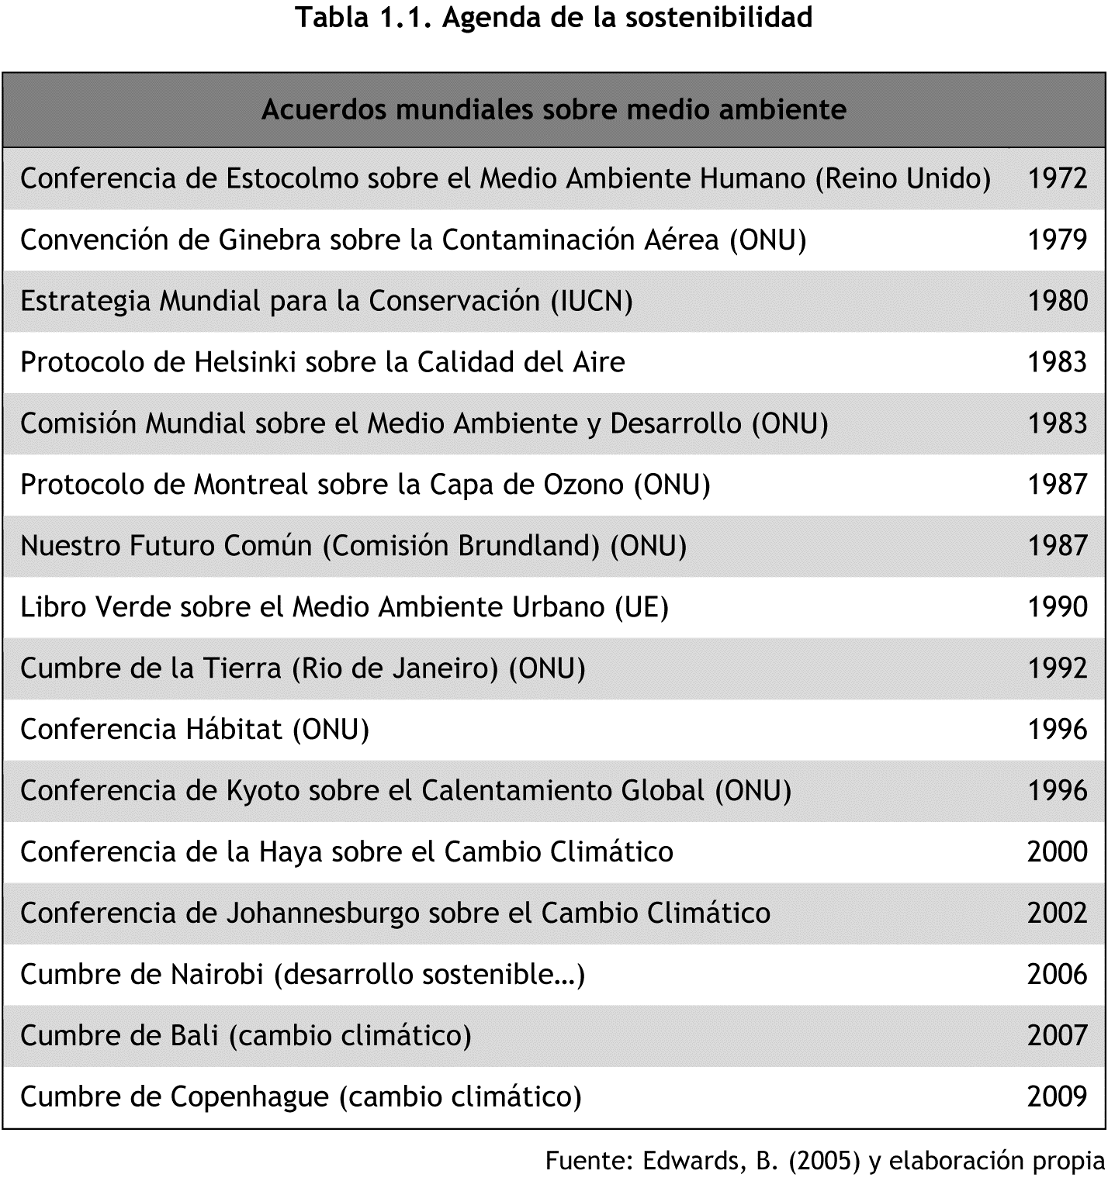

Table 2. Results of mesh independence study
Mesh | Number of cells | Relative error
1 | 100 000 | 8%-
2 | 300 000 | 5%
3 | 900 000 | 2%
4 | 1 200 000 | -

  - Equations
Formulas and/or equations will be inserted using the equation editor built into Microsoft Word and will have a number in parentheses to their right indicating their order, for example:
(1)
  - How to cite within the text?

To reference AUTHORS: the last name and the year in parentheses, e.g., (Margot, 2024)

To reference SOFTWARE: the title of the software in CAPITAL LETTERS, without the year or author.
- About the References

References should be presented alphabetically by last name, without differentiating between print and electronic sources, using the following style: no bullet points, hanging indent, and especially if the reference list is lengthy, a smaller font size than the rest of the article (font Arial 9).

For citations and bibliographic references, the use of APA 7th edition style is recommended. A summary guide on how to reference and cite can be found at the following link: https://libguides.csudh.edu/citation/apa-7.

A more detailed guide to APA 7th edition style is available at the following link: https://normas-apa.org/wp-content/uploads/Guia-Normas-APA-7ma-edicion.pdf.
- Conclusions
We hope this template will be useful to you. If you have any doubts or questions, please do not hesitate to contact us directly per e-mail: secrecon@mot.upv.es.
Please do not forget the deadlines:
19th April 2026: 1st version of paper for peer review
21st June 2026: Final version of the paper

DO NOT NUMBER THE PAGES, PLEASE. THIS WIIL BE DONE BY THE EDITORIAL.

We thank you for your cooperation

